Magnetometer Data Upload
The sites are able to send magnetometer data by using API calls.
The URL of the API endpoint to upload magnetometer data is:

POST
http://api.wow-uat.adfs.net/api/bulkimportfiles/aurorawatchnet?qqFile={{qqFile}}&siteId={{ siteId}}&siteAuthenticationKey={{siteAuthenticationKey}}
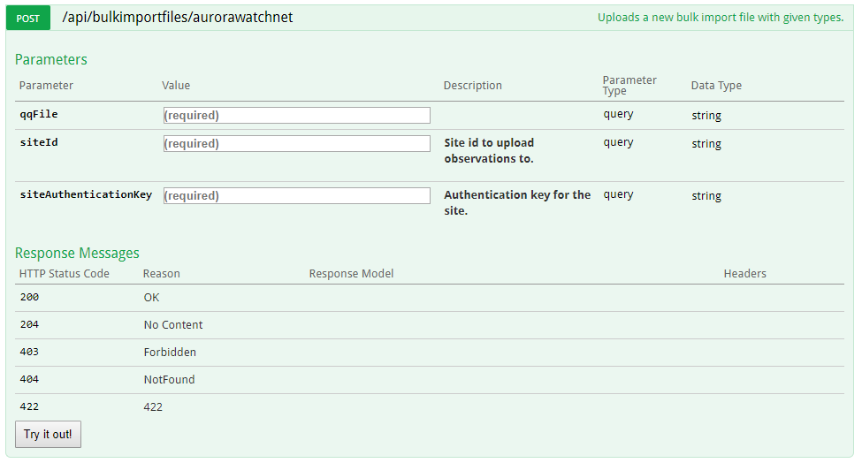
Figure 1- Endpoint definition
For Test purposes, you can use an application like “Postman” (a Google Chrome extension version of the application is used in this documentation) [Link]
Postman is a simple application which is very easy to use, like a simple browser.
It has an address bar which we will use to write our API endpoint URL, Http Method selection dropdown (for this test we may need to select Post from this dropdown) and a send button.
To upload magnetometer data, you need to paste the API endpoint URL to the address bar.
Also you need to modify the texts which are in brackets.
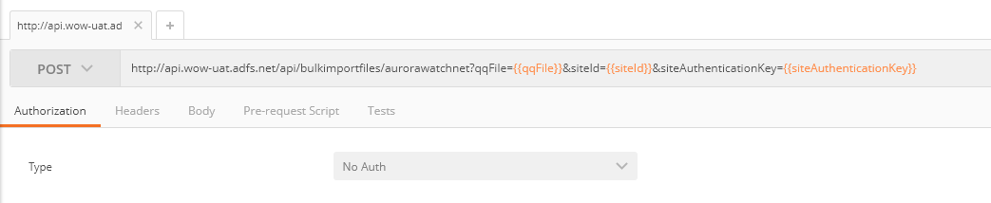
Figure 2- Postman Set Url
Under address bar there is a tab panel. You need to select Body.
Under the body tab, select binary format.
To choose the file to upload you need to click the Choose Files button.
This button will open a window to select the file.
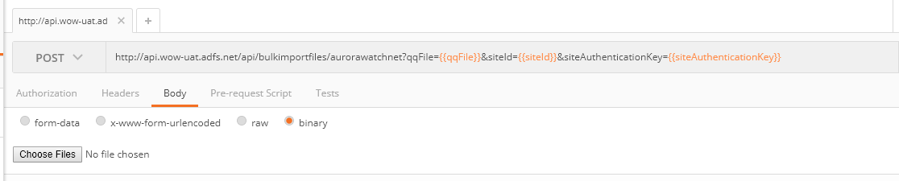
Figure 3- Postman Set Body
After your file selection, the name of the file becomes visible, as below.
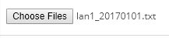
Figure 4 - Selected file

By clicking the send button near the address bar, the upload will start.
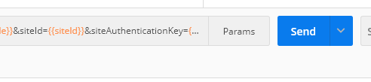
Figure 5- Send Http Request
The time it takes to upload the file is dependant on the file size.
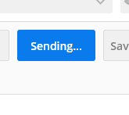
Figure 6 - Waiting Http Response

If the upload is successful it will return a status result (200 OK), as below.
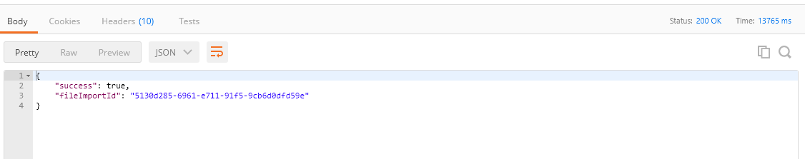
Figure 7- Successful file upload result

After the file upload, there will be a slight time delay in viewing the uploaded data in WOW, dependant on the uploaded file size.
How to obtain API endpoint variables.
{{qqFile}} : is the name of your file. i.e : myObservationFile.txt
{{siteId}} : is located in dashboard under the site name i.e : d3ee7e8e-0250-e711-9400-0003ff7b54db
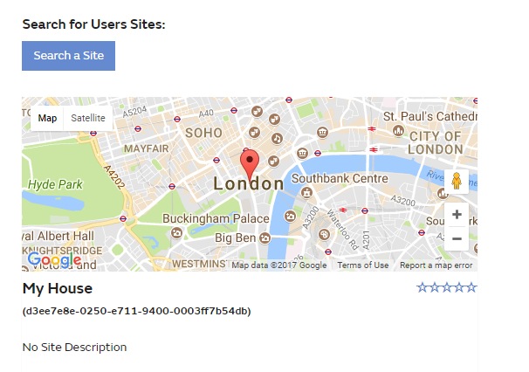
Figure 8- Site Id

{{SiteAuthenticationKey}} : each site on the system has its own Authentication Key. This key is located in ‘Site Details’ within the Edit Site page. If the Authentication Key text box is empty, you should define a key to be able to upload data.
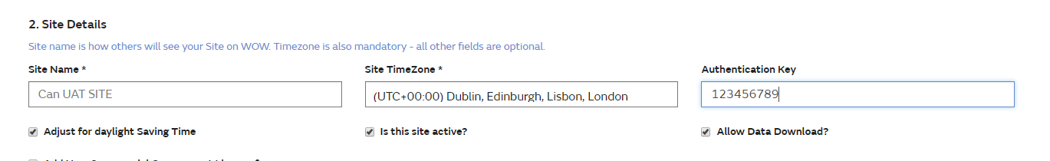
Figure 9- Authentication Key Settings

